Point ID | BE011 |  |  | Aerial Target |  | Coordinate System
Project No. | R030675 |  |  | LiDAR Ground Control |  | NAD83(2011)
Project Name | Klamath Topobathy |  | X | LiDAR QC Point |  | UTM10
State | California |  |  | New Control |  | NAVD88
County | Humboldt |  |  | Photo ID |  | GEOID12B
Quad | Somes Bar |  |  | Published Control |  | Meters

Northing | Easting | Elevation
4580715.111 | 458678.307 | 124.280

Operator | Camden Beeghly |  | Date (MM-DD-YYYY) | 06-10-2018
Receiver Model | Trimble R8 |  | RMSE Hz
Receiver S/N | 5033444846 |  | RMSE Z
Antenna Height | 1.995m |  | GPS Method | FS

PHOTOS:
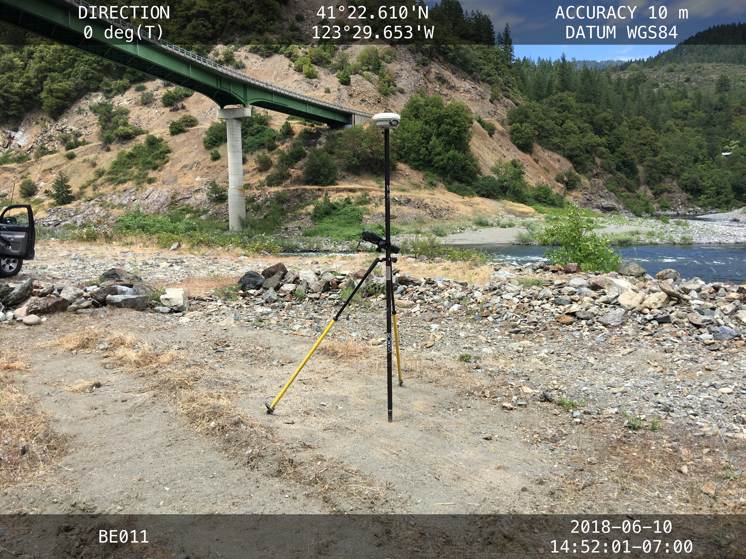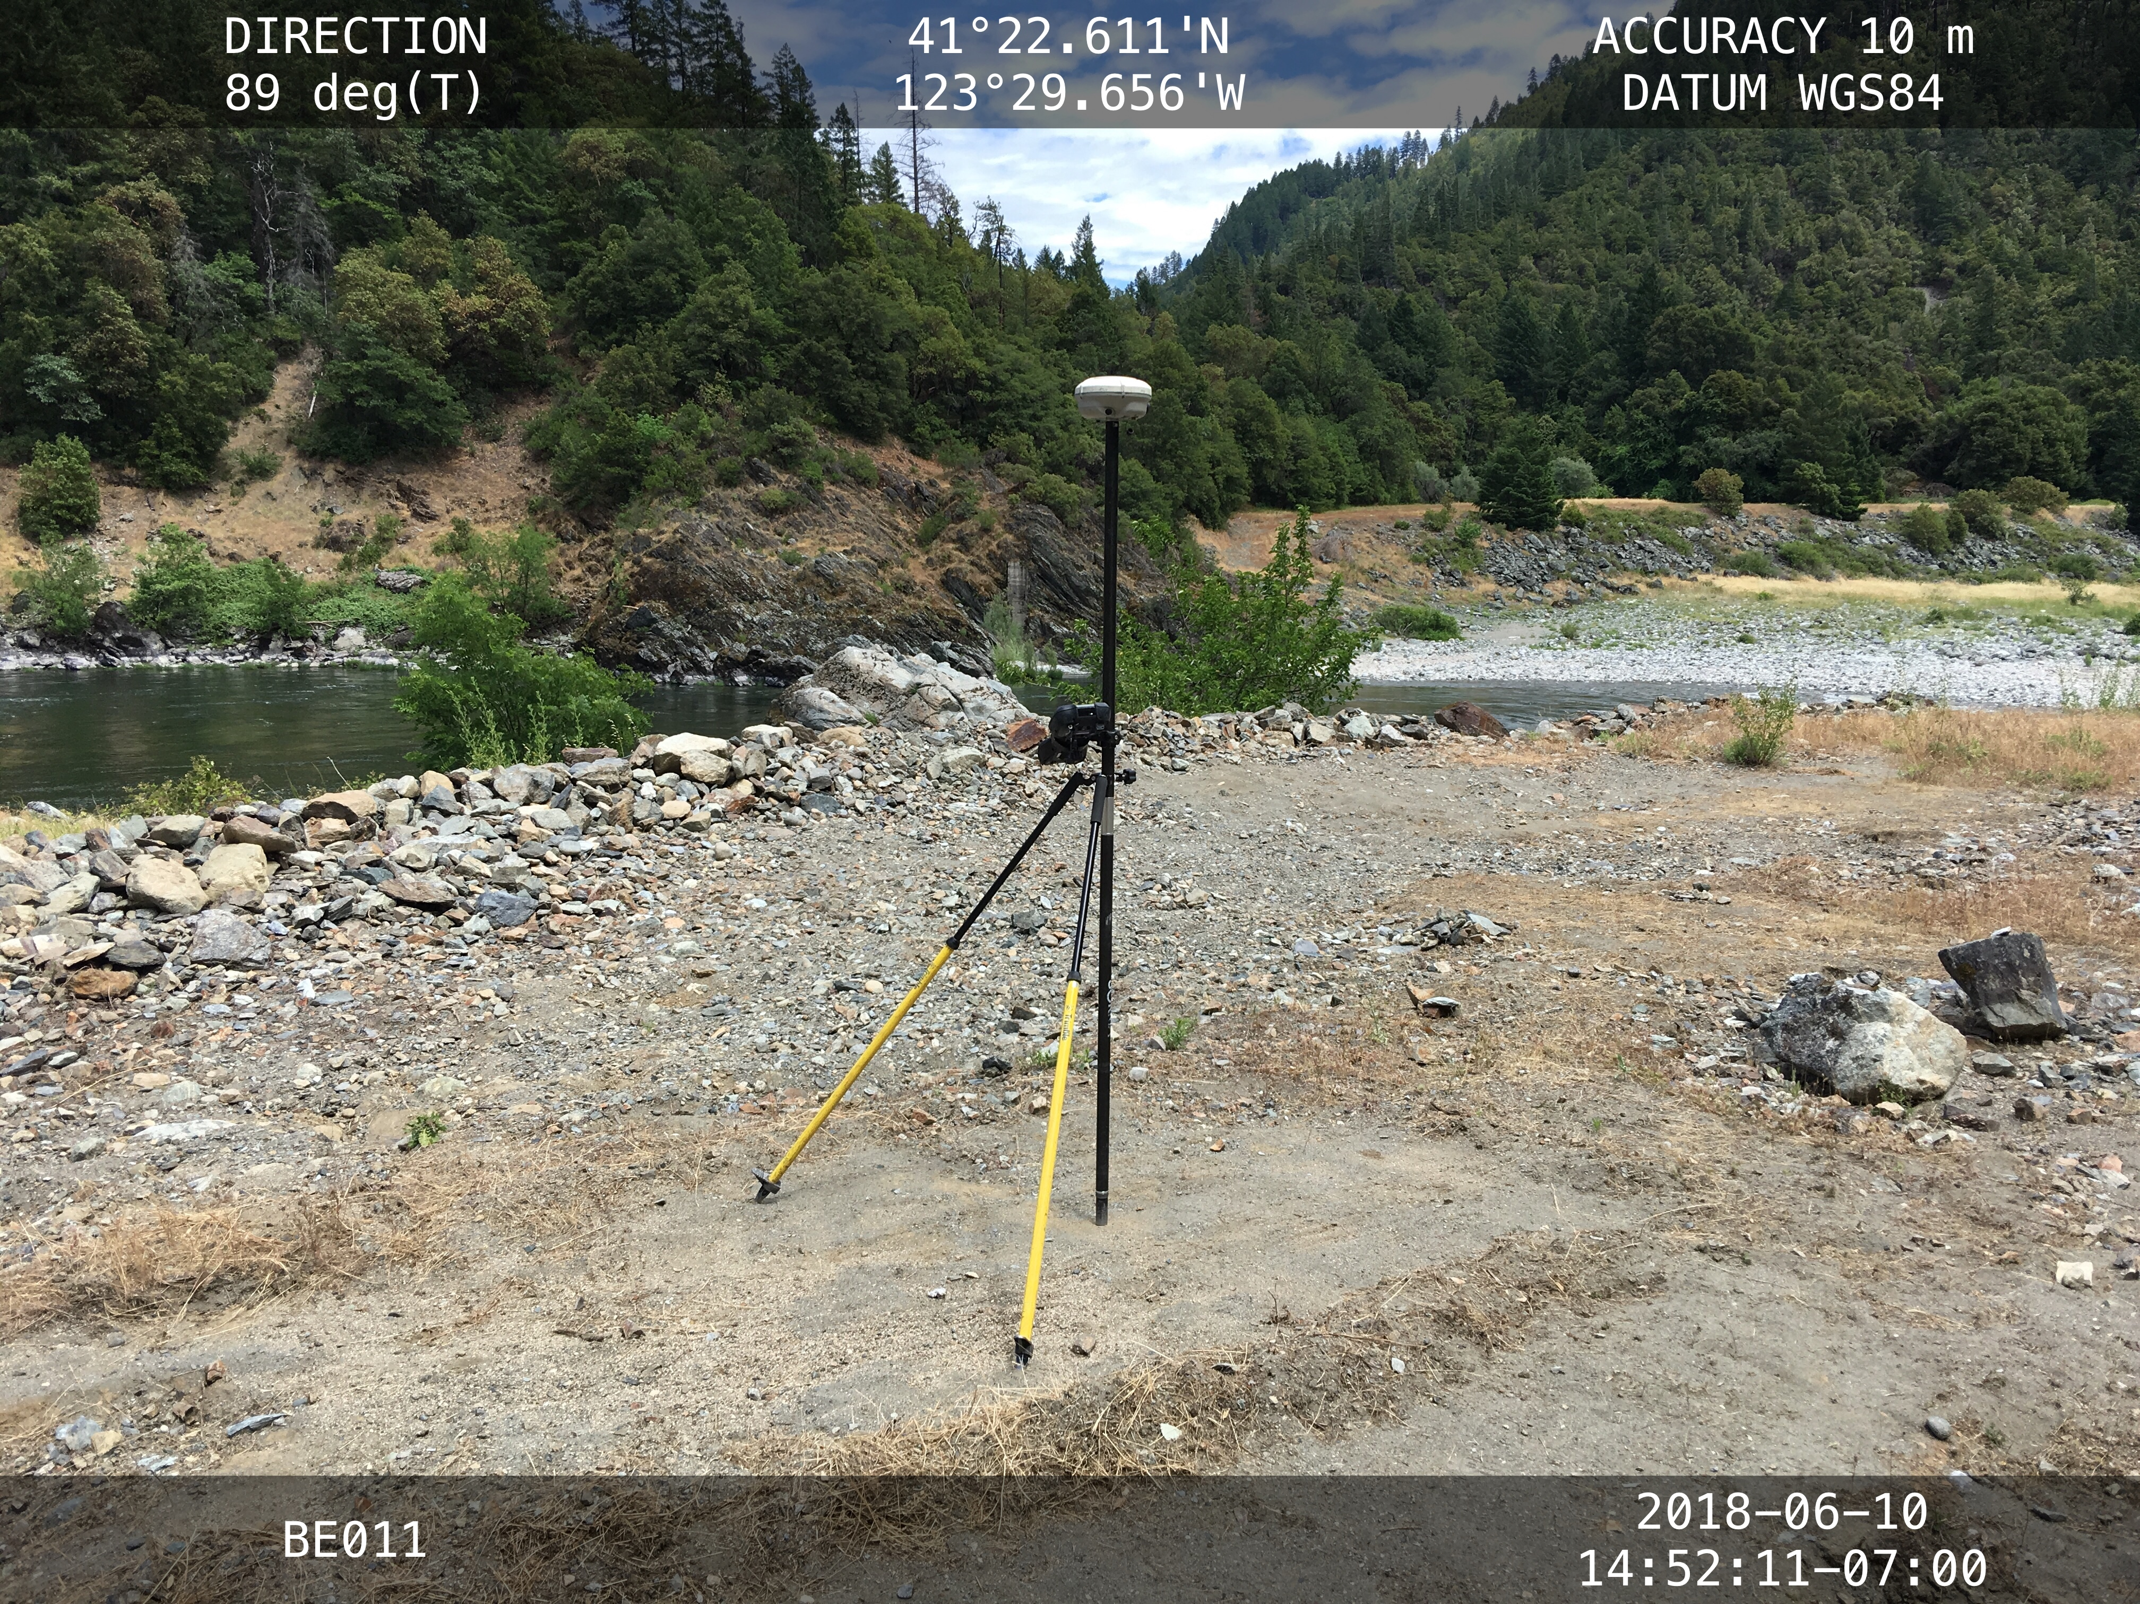 | 